4th Open Euro - Asia cheerleading
championship 2018

Package «Сomfortable»
«Сomfortable» includes: Breakfast, Lunch and Dinner.
Transportation airport - hotel - airport Leaving in hotel «Almaty/ Astana»
three nights
Transportation between hotel and venue, Culture  Exchange, Tour the city. | Registration Fee USD250.00/PAX

2 November | 3 November | 4 November | 5 November
Arrive in Almaty/ City tour | Sightseeing  Practice/ master class | Competition | Transfer to airport

EXTRA NIGHT: with meal and transportation Per….
«Comfortable» USD 62.50/PAX,.

Detailed information about packages

Package «Сomfortable»
Transfer to a comfortable bus, airport-hotel-airport.

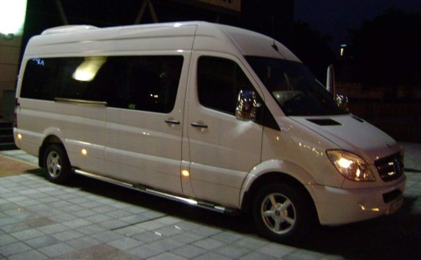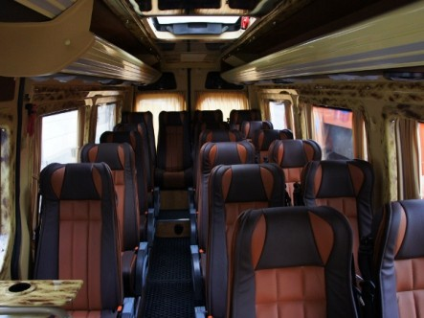
Hotel «Almaty/ Astana», Accommodations (2 pax / 1 room).

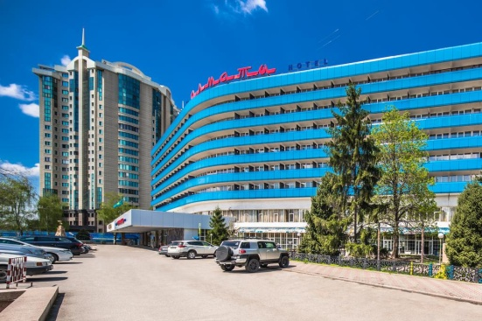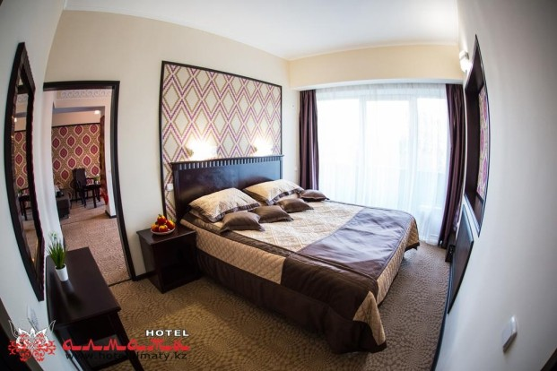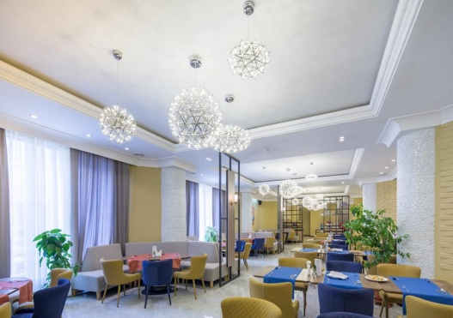

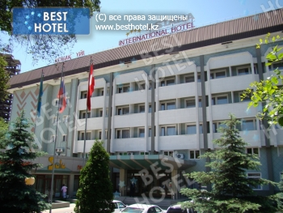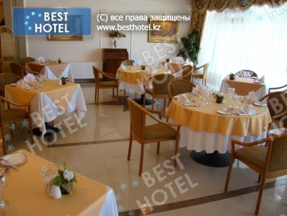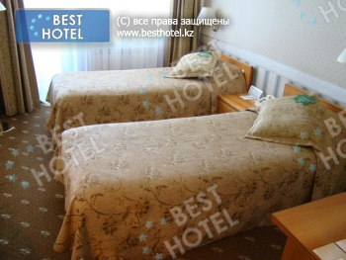

Detailed information about packages

City tour
Excursion for two identical packages, up to 5 hours.
On the tour you will visit the objects such as the skating rink Medeo
The new president of the area, the central mosque of Almaty, the name of the park 28 Panfelevtsev, Holy Ascension Cathedral and many
Almaty other attractions.

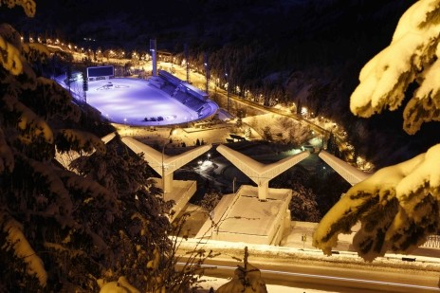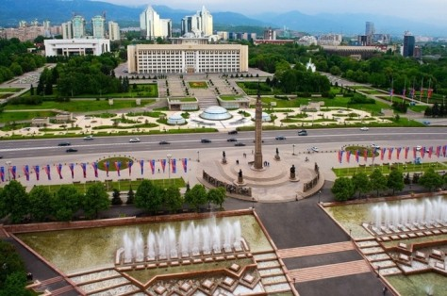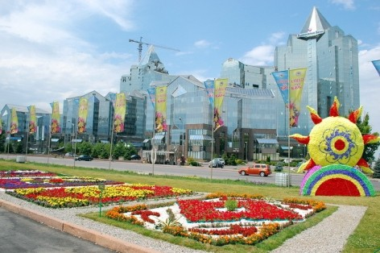

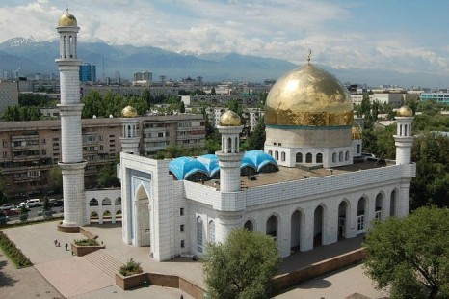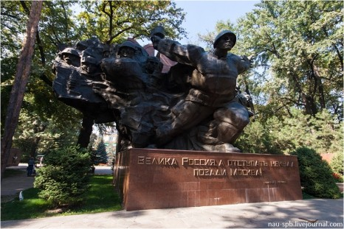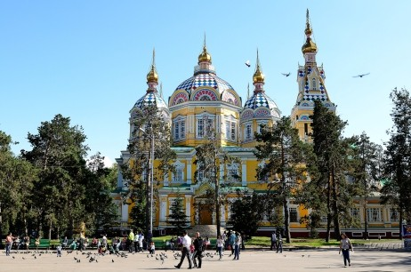

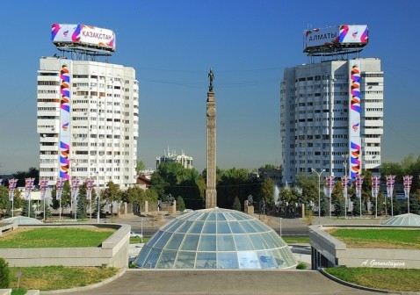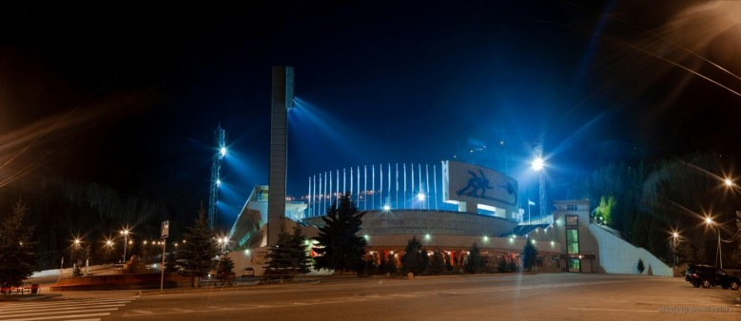

Cancellation Policy

Cancellation Policy
Cancellations received aGer October 20th 2018 will result in a FULL FORFEITURE of all monies paid. Cancellations are accepted in writing Organizer name of the Kazakhstan National Federation of
Cheerleading. We will not accept cancellations by phone. I have read the cancellation policy and understand and accept its contents. I have also advised all participants, parents and chaperones of my group of this cancellation policy
Signature

Contact person

Contact person
Name: Donskaya Olga
tel.: +7 707 816 57 28
e-mail: admi.tetcheer@mail.ru

Application for accommodation is received in writing by mail to the above. The application form a†ached to the le†er.

